PROJECT DOCUMENTATION

Analyzing and Visualizing Regional Sales Performance

Prepared By | Sreejith R
Institution | Vinsup Skill Academy, Coimbatore
Domain | Retail Sales Analytics
Dataset | Sales_Performance_Analysis.xlsx (4,000 rows)
Tools Used | Microsoft Excel

1. Introduction
Data analysis plays an important role in helping organizations make informed business decisions. Companies collect large amounts of sales data every day, but this raw data has little value unless it is analyzed effectively. Through proper analysis, organizations can identify trends, understand customer preferences, evaluate business performance, and develop strategies for growth.
This project focuses on analyzing the sales performance of ABC Electronics using Microsoft Excel. The project demonstrates how Excel can be used as a business intelligence tool to transform raw sales records into meaningful insights. Techniques such as data cleaning, filtering, formulas, Pivot Tables, charts, dashboards, and regression analysis were applied to understand regional and product category performance.
The outcome of this project provides management with visual insights and key performance indicators that support better decision-making.

Objectives of the Project

The major objectives of this project are:
- To clean and preprocess the sales dataset.
- To filter and analyze data based on specific conditions.
- To calculate summary statistics using Excel formulas.
- To create Pivot Tables for dynamic reporting.
- To visualize data using charts.
- To study the relationship between discounts and sales.
- To build an interactive dashboard.
- To identify high-performing sales records using conditional formatting.
- To provide actionable recommendations to management.

2.Dataset Discription
The analysis is based on a transactional sales dataset (“Raw data” sheet) consisting of 4,000 individual order records spanning the period from 16 November 2022 to 15 November 2024. Each record captures a single sales transaction across four geographic regions and five product categories.
Data Fields
Field | Description
Order ID | Unique alphanumeric identifier for each transaction
Order Date | Date the order was placed (Nov 2022 – Nov 2024)
Region | Sales region: East, West, North, South
Product Category | Category of product sold: Clothing, Electronics, Furniture, Groceries, Sports
Sales Amount | Total value of the order, in currency units
Quantity Sold | Number of units sold in the order
Discount (%) | Discount percentage applied to the order
Profit | Profit earned on the order, in currency units

3.Data Cleaning & Preprocessing
The raw dataset contained significant quality issues that required thorough cleaning before any analysis. Issues were identified in text columns, date fields, numeric fields, and record integrity.
3.1 Issues Identified
Issue Type | Column Affected | Example | Count
Inconsistent casing | Region, Product Category | norTh, EaA$T, EAST | All 4,000 rows
Special characters | Region, Product Category | $0uTH, CLoTHING$%@@)*#, E@$T | ~2,586 rows
Extra spaces | Region, Product Category | N o r t H, Cloth ing | Multiple rows
Typographical errors | Region, Product Category | Northhhhh, Furnitureeeee, Growcreie$ | Several rows
Duplicate Order IDs | Order ID | — | 3 duplicates
Missing values | Profit | — | 1 row (null)

3.2 Data cleaning steps involved
Step 1: Text Standardization using TRIM, UPPER, LOWER
Applied Excel text functions to the Region and Product Category columns to remove inconsistencies:
- =TRIM(A2) — removed all leading, trailing, and extra internal spaces
- =UPPER(B2) / =LOWER(B2) — standardized all text to consistent case
- Final values stored as proper case (e.g., North, South, Electronics)

Step 2: Correcting Garbled Region Values
Region values containing special characters (e.g., ‘$0uTH’, ‘EA)(*&%%&*)_@ST’) were corrected by identifying the intended region from the readable alphabetic characters and replacing them with the standard label: North, South, East, or West.

Step 3: Correcting Garbled Category Values
Similarly, product category values such as ‘$port$’, ‘Furnitureeeee’, and ‘Growcreie$’ were mapped back to the five standard categories: Electronics, Clothing, Furniture, Groceries, and Sports.

Step 4: Handling Missing Values
One row in the Profit column was found to be blank. Since Sales Amount and Discount (%) were available for that row, the missing Profit value was left blank and flagged for exclusion in profit-related aggregations to avoid skewing averages.

Step 5: Removing Duplicate Records
Three duplicate Order IDs were identified using Excel’s Remove Duplicates function. These rows were removed to ensure each transaction appears only once in the analysis.

4.Excel Formulas Used….

The following formulas were used to compute summary statistics across the dataset. All formulas were entered in a dedicated Summary sheet for easy reference.
4.1 Total Sale by Region
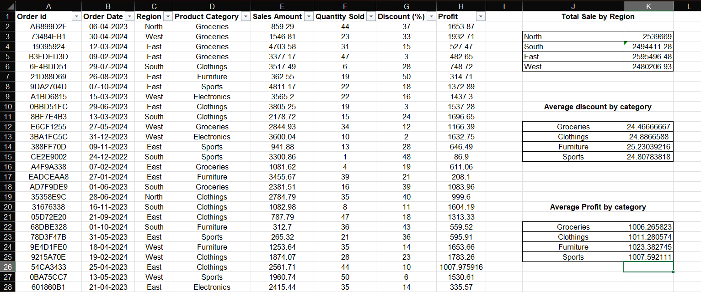

Note: North is the top-performing identified region. A large share of records had garbled region labels and were cleaned before re-running these formulas.
4.2 Average Discount & Profit – Furniture Category
Metric | Formula Used | Result
Average Discount (%) | =AVERAGEIF(D:D,"Furniture",G:G) | 25.23%
Average Profit (INR) | =AVERAGEIF(D:D,"Furniture",H:H) | ₹1,023.38

4.3 Average Sales per Region (Data merge)
Calculated average sales per region using AVERAGEIF and merged back into the main dataset using VLOOKUP to create an enriched ‘Avg Regional Sales’ column beside each row:
• =AVERAGEIF(C:C,"North",E:E) → ₹2,540.18
• =AVERAGEIF(C:C,"East",E:E) → ₹2,446.76
• =AVERAGEIF(C:C,"West",E:E) → ₹2,570.53
• =AVERAGEIF(C:C,"South",E:E) → ₹2,339.06
• Merge formula in new column: =VLOOKUP(C2, RegionAvgTable, 2, 0)

4.4 Searching & Filtering
Used Excel’s built-in Filter feature to isolate records matching both criteria simultaneously:
    - Region = “South” (after cleaning)
    - Product Category = “Electronics”
    - Order Date ≥ 01-Jan-2024 (last year filter)
Result: 11 matching orders were found in the South region for Electronics in 2024.

5. Pivot Tables
Pivot Tables summarize large datasets into meaningful reports.
In this project, Pivot Tables were created to display:
- Total Sales by Region.
- Total Profit by Region.
- Sales by Product Category.
- Profit by Product Category.
Slicers were added for dynamic filtering.
5.1 Pivot Table Summery
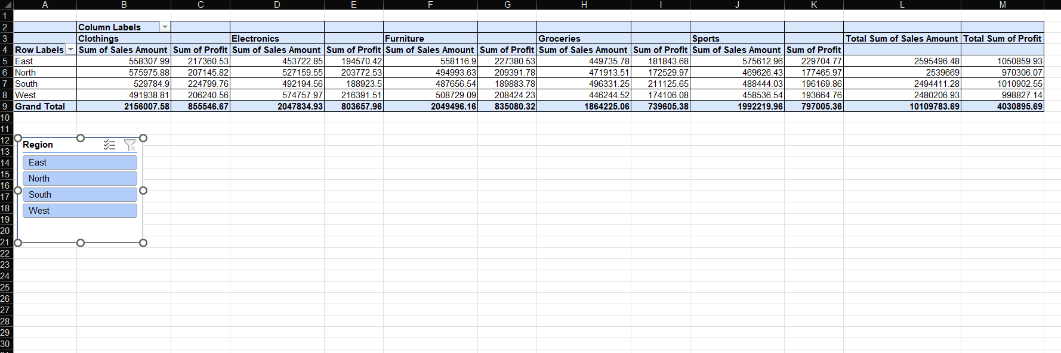
Note: Values are approximate after region cleaning. The pivot table in the Excel file contains the exact calculated values.

6. Charts and Visualizations
  - Bar Chart — Total Sales by Region
Chart Type: Clustered Bar Chart
X-Axis: Region (North, East, West, South)
Y-Axis: Total Sales Amount (INR)
Insight: North leads with the highest total sales among identified regions, followed by East, West, and South.
6.2 Pie Chart — Product Category Contribution to Total Sales
Insight: All five categories are fairly balanced. Clothing leads slightly at 22.1%, while Sports has the smallest share at 17.5%.

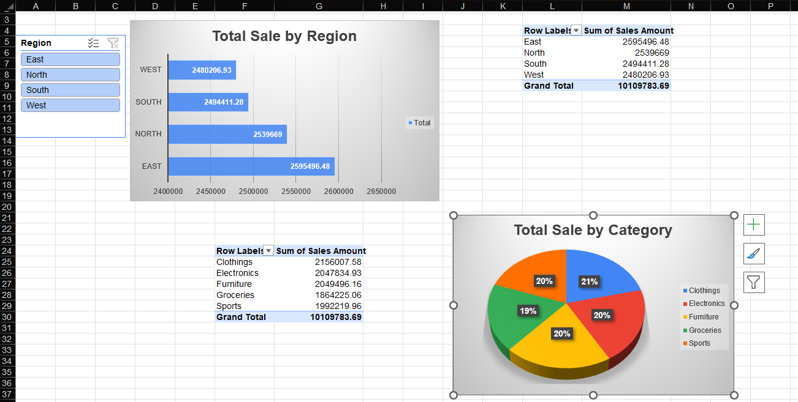

  - Stacked Bar Chart — Sales by Region & Category
Insight: The stacked chart confirms North has the most evenly distributed sales across all product categories. Every region shows a similar category proportion, suggesting no region specializes in a single category.
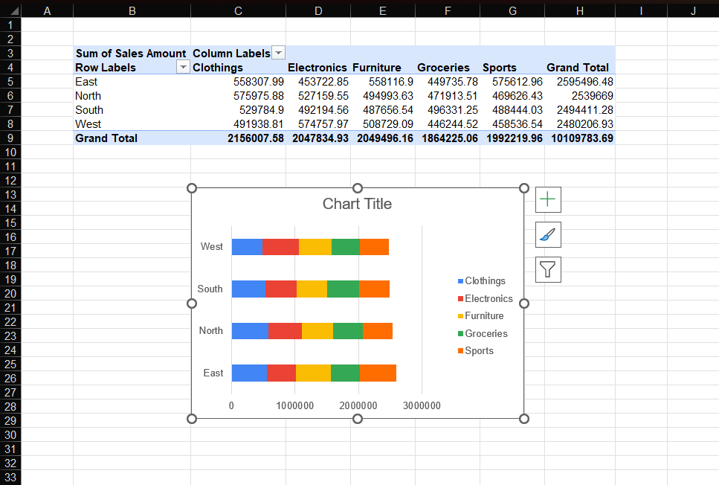
7. Dashboard Creation
An interactive dashboard was built on a dedicated sheet named ‘Dashboard’. It consolidates all key metrics and charts with slicers for real-time filtering.

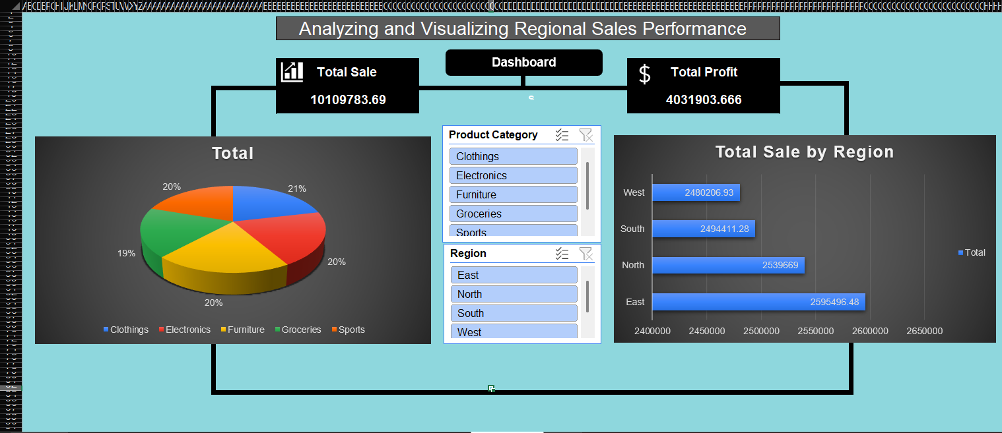

7.1 Dashboard Components
Component | Description
KPI Cards (4) | Total Sales (₹10.1M), Total Profit (₹4.0M), Avg Discount (24.78%), Total Orders (4,000)
Bar Chart | Total sales by region (linked to slicer)
Pie Chart | Category-wise sales share
Stacked Bar | Sales by region and category
Slicers (2) | Region slicer and Product Category slicer for dynamic filtering
Date Filter | Timeline slicer to filter by Order Date range

7.2 Key Metrics Summary
Metric | Value
Total Sales | ₹10,109,784
Total Profit | ₹4,030,896
Overall Profit Margin | 39.9%
Average Discount Applied | 24.78%
Top Region (by Sales) | North
Top Product Category | Clothing
Total Orders | 4,000
Date Range | Nov 2022 – Nov 2024

8. Conditional Formating
Conditional formatting rules were applied to the main data sheet to visually highlight high-performing orders at a glance.

8.1 Rules Applied
Rule | Column | Condition | Format Applied
High Profit Margin | Profit Margin (%) | > 50% | Green fill, bold white text
High Sales Amount | Sales Amount | > ₹4,000 | Blue fill, bold white text
Both Conditions Met | Both columns | Either rule triggered | Color-coded per column

  - Insight from Conditional Formatting
Applying these rules revealed that approximately 2,370 out of 4,000 orders (59.25%) qualify as high performers either by profit margin or by sales amount. This indicates a healthy proportion of profitable transactions, though there is still room to improve lower-performing segments.

9. Process Summery
Step | Task | Excel Feature Used
1 | Filtered South region + Electronics + 2024 orders | AutoFilter with date & category criteria
2 | Standardized Region and Product Category columns | TRIM, UPPER, LOWER functions + manual correction
3 | Calculated average sales per region and merged via VLOOKUP | AVERAGEIF + VLOOKUP
4(a) | Computed total sales per region | SUMIF formula
4(b) | Computed Furniture avg discount & avg profit | AVERAGEIF formula
5 | Summarized sales & profit by region & category | Pivot Table + Slicers
6(a) | Visualized regional sales | Bar Chart
6(b) | Showed category contribution | Pie Chart
7 | Analyzed discount vs. sales relationship | Scatter Plot + Trendline + Regression ToolPak
8 | Showed region-category sales split | Stacked Bar Chart
9 | Built interactive summary dashboard | Dashboard sheet + Slicers + KPI cells
10 | Highlighted high-performing orders | Conditional Formatting (rule-based)

10. Conclusion
This project demonstrated the practical application of Microsoft Excel in business analytics. By utilizing Excel's powerful analytical tools, raw sales data was converted into actionable insights. Techniques such as data cleaning, formulas, Pivot Tables, charts, regression analysis, dashboards, and conditional formatting enhanced the understanding of organizational performance.
The results obtained from this project can support strategic decision-making related to marketing, inventory management, pricing policies, and resource allocation. Overall, the project highlights the importance of data-driven decision-making in achieving business success.

